Source code:

import java.util.ArrayList;  
import java.util.HashMap;  
import java.util.List;  
import java.util.Map;  
import java.util.Scanner;  
  
public class SurveySystem {  
  
 // Creating Question set  
 private static Map<String, List<String>> *surveyResponses* = new HashMap<>();  
  
 // Get registered customers  
 private static List<String> *registeredCustomers* = new ArrayList<>();  
  
 public static void main(String[] args) {  
 // Questions for survey  
 Scanner scanner = new Scanner(System.*in*);  
 System.*out*.println("---------------------------------------------------------------------------------------------------------------------------------------------------------");  
 System.*out*.println("Enter the survey questions (one per line, type 'done' when finished):");  
 String question = scanner.nextLine();  
 while (!question.equalsIgnoreCase("done")) {  
 *surveyResponses*.put(question, new ArrayList<>());  
 question = scanner.nextLine();  
 }  
  
 // mail registration  
 System.*out*.println("---------------------------------------------------------------------------------------------------------------------------------------------------------");  
  
 System.*out*.println("Enter the registered customers (one email address per line, type 'done' when finished):");  
 String customerEmail = scanner.nextLine();  
 while (!customerEmail.equalsIgnoreCase("done")) {  
 *registeredCustomers*.add(customerEmail);  
 customerEmail = scanner.nextLine();  
 }  
  
 // Question & Answer process  
 for (String surveyQuestion : *surveyResponses*.keySet()) {  
 System.*out*.println(surveyQuestion);  
 List<String> responses = *surveyResponses*.get(surveyQuestion);  
 for (String customer : *registeredCustomers*) {  
 System.*out*.print(customer + ": ");  
 String response = scanner.nextLine();  
 responses.add(response);  
 }  
 }  
  
 // Send promotional emails to the target audience  
 System.*out*.println("-----------------------------------------------

----------------------------------------------------------------------------------------------------------");

System.*out*.println("Sending promotional emails to the target audience...");  
 for (String customer : *registeredCustomers*) {  
 System.*out*.println("Sent promotional email to " + customer);  
 }  
  
 // Run the "Online Survey"  
 System.*out*.println("---------------------------------------------------------------------------------------------------------------------------------------------------------");  
  
 System.*out*.println("Running the online survey...");  
 for (String surveyQuestion : *surveyResponses*.keySet()) {  
 List<String> responses = *surveyResponses*.get(surveyQuestion);  
 System.*out*.println(surveyQuestion);  
 for (String response : responses) {  
 System.*out*.println("- " + response);  
 System.*out*.println("---------------------------------------------------------------------------------------------------------------------------------------------------------");  
  
 }  
 }  
 System.*out*.println("---------------------------------------------------------------------------------------------------------------------------------------------------------");  
  
 }  
}

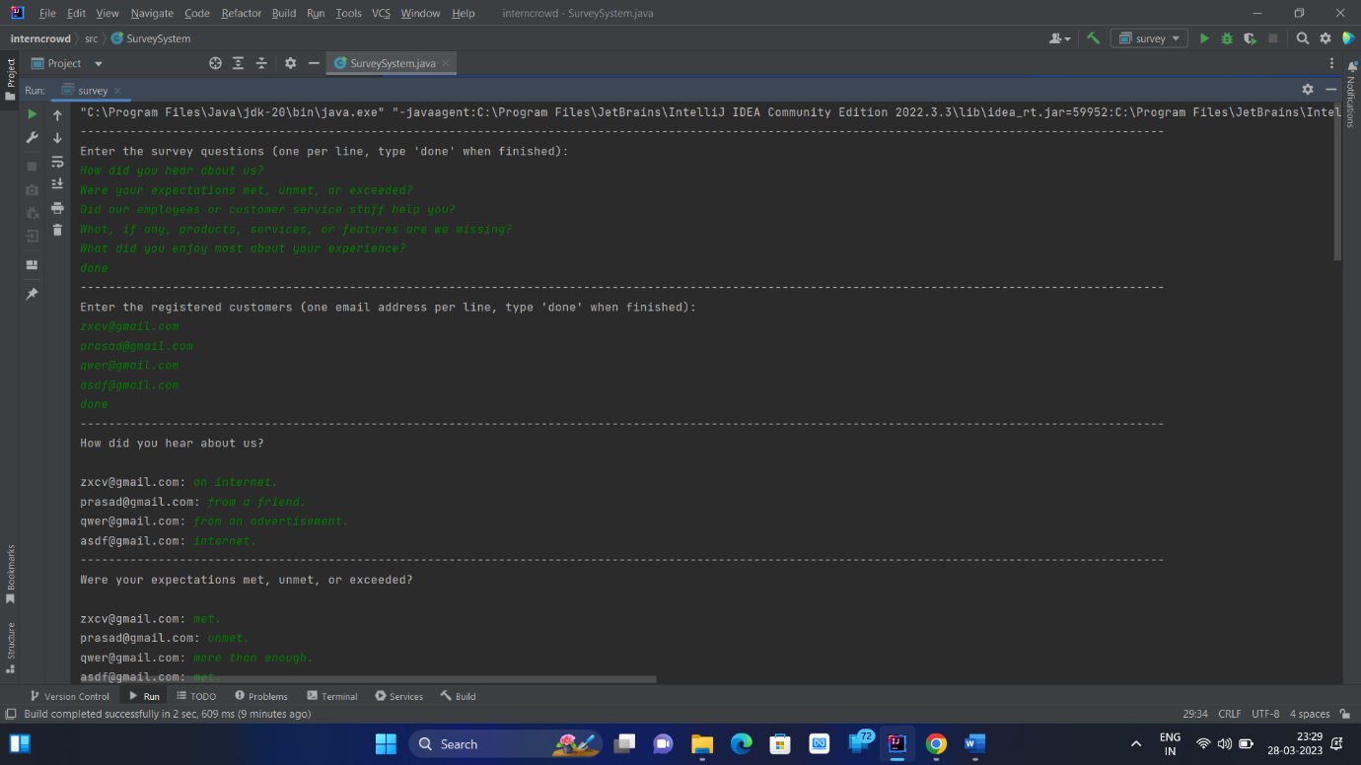Output:

